Audition Information

NZ Diploma in Performing Arts – Māori and Pacific Dance (L6) for 2022 intake

Due to the uncertain times, we are facing, we are accepting online video auditions for those applicants who are unable to attend the Live Auditions on Monday, November 15, 2021, in Porirua.

Online Audition – Film a short clip:
- Introduce yourself (name, age, nationality)
- Select any Māori or Pacific song to sing that best showcases you (it can be anywhere between 1-2 minutes)
- Showcase your talents as a dancer and how you move – as long as it best showcases you

Once you have provided this you can send to Taofi.Nehemia@whitireia.ac.nz

All online submissions are to be submitted by 11 February 2022. We will then arrange a Zoom interview time with you, with the tutors.

LIVE AUDITION & INTERVIEW:
You will join a workshop with tutors and current students of the programme. This allows the staff to see how well you work within the group. A follow up interview will then take place with all tutors once the audition is finished.

What to wear:
- Black t-shirt
- Black shorts
- Ie lavalava, pareu or sarong
- Hair must be neat and tidy

Details are as follows:
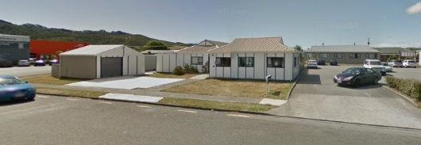
Monday 15th November 9am-2pm Room D350 (Entry 6)
Whitireia Community Polytechnic Elsdon

NB: Image to the side is where audition will take place (opposite the back of Mitre 10).

If you have any questions regarding the auditions, please do not hesitate to contact me.
NB. Do not worry if you have no experience in any of the above ‘genres’.

Taofi Nehemia, BAppA
Siva Samoa and Team Leader
Whitireia Performing Arts
Email: Taofi.Nehemia@whitireia.ac.nz

