New Zealand Diploma in Performing Arts
(Musical Theatre)

Online Auditions Due: Friday, 11 February 2022

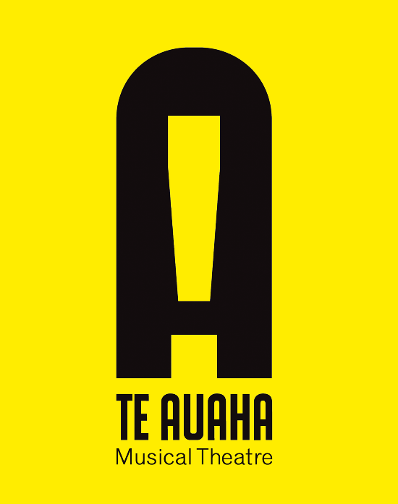

Audition Information
For this audition you will need to create an online application package. This will be sent as an email attachment, so please include the following:
- A formal cover letter addressed to Kate Marshall (Lead Tutor – Musical Theatre) introducing yourself and what songs and monologue you are auditioning with in PDF format.
- PDF copy of your song choices
- PDF copy of your monologue
- PDF copy of your CV with headshot (if you have one)
- Individual videos of your selected songs
- Individual video of your selected monologue
- If you have a dance background please prepare a short video in your chosen genre. If you do ot have dance training, please leave this section out.

All material is to be emailed to kate.marshall@whitireia.ac.nz

